Process Manual

1. Install R 3.6.1
2. Download/save the files
3. Open R
4. Use the function setwd(“Location where the files were saved /Downloaded”) as shown below.



6.Open the files - “main.csv”,” functions.csv” and “nick_functions.csv”, and select ‘Source of Save’ in ‘main.R’.

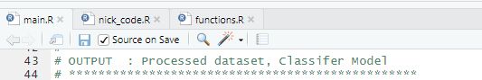

The main R file is where execution initialises, to run the program click save within main.R

Run the program from main.R initially. Once those models and outcomes have completed processing, open the file neural_networks_new.R, click ‘Source on Save’ and press save. This will output all values and details for the neural network.

N.B. - Please note that execution from pre-processing to completion of neural network may take some time.